Task 6 – Design the Inheritance Hierarchy (4 Marks)

1. Hierarchy and type of inheritance
- Vehicles: Vehicle (abstract) ← TwoWheeler, Car ← ElectricCar.
  - Vehicle → TwoWheeler and Vehicle → Car = hierarchical (two subclasses of one parent).
  - Vehicle → Car → ElectricCar = multilevel.
  - ElectricCar implements Chargeable – Java gives multiple type inheritance only through interfaces.
- Users: User (abstract) ← Student, Staff, Visitor = hierarchical.
Why ElectricCar extends Car: an EV is a car for every parking purpose (same rate, same slot) and adds only charging.

2. UML class diagram
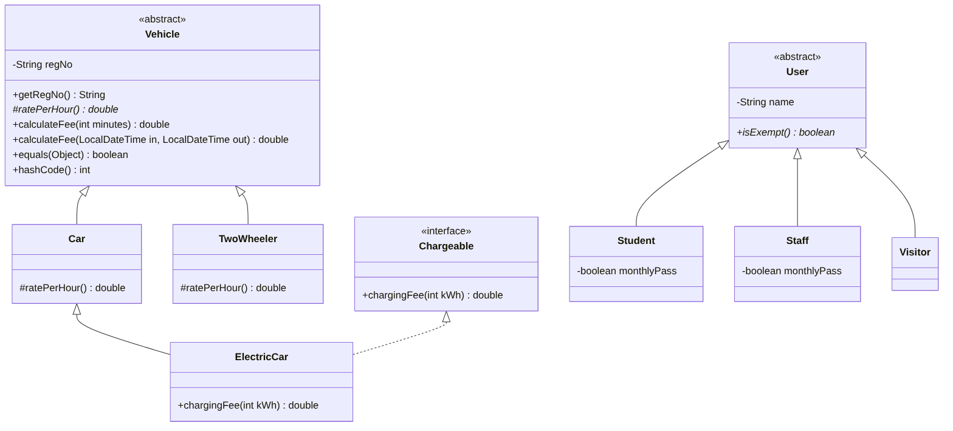
UML class diagram
(Task06/uml_class_diagram.png, source uml.mmd. <<abstract>> = abstract class, italic = abstract method, dashed arrow = implements, solid hollow arrow = extends.)

3. What is inherited and what is added
Class | Inherits | Adds / overrides
Vehicle | Object (equals, hashCode, toString – overridden) | regNo, getRegNo(), calculateFee(...) (shared), abstract ratePerHour()
TwoWheeler | regNo, getRegNo, calculateFee, equals… | ratePerHour() = 10
Car | same | ratePerHour() = 30
ElectricCar | everything in Car (rate 30) | chargingFee() from Chargeable
Student / Staff | name, getName() | monthlyPass, isExempt()
Visitor | name | isExempt() = false

4. Use of super
- Constructors: TwoWheeler(String regNo) { super(regNo); } – the parent’s constructor validates and stores the regNo (the final private field cannot be set by the subclass).
- Fields: the subclass reaches regNo only through getRegNo() because the field is private – super.regNo would not compile. This is encapsulation working.
- Methods: super.method() calls the parent’s version when a subclass overrides but still wants the parent’s behaviour (e.g. a subclass fee = super.calculateFee(m) + surcharge).

5. Constructor order for new ElectricCar("TN03C3") (real trace)
Task06/ConstructorTrace.java:
new ElectricCar("TN03C3"):
1. Vehicle(String) regNo = TN03C3
2. Car(String) after super()
3. ElectricCar(String) after super()
Constructors run top-down: ElectricCar(String) is entered first, but its first statement super(regNo) runs Car(String), whose first statement super(regNo) runs Vehicle(String). Vehicle’s body completes first, then Car’s, then ElectricCar’s – so a parent is always fully built before the child uses it. (Object() runs before Vehicle.)

Alternative Concept and Complexity Analysis – composition (Vehicle has-a VehicleType)
class VehicleType { final String name; final double ratePerHour; boolean chargeable; ... }
class Vehicle { final String regNo; final VehicleType type;
double calculateFee(int minutes) { return ((minutes + 59) / 60) * type.ratePerHour; } }
Vehicle v = new Vehicle("TN01", VehicleType.CAR); // only 3 shared VehicleType objects exist
 | Inheritance (mine) | Composition
Add a vehicle type with a different rate only | write a new class (≈4 lines) | add one data row: new VehicleType("BUS", 50) – no new class, no recompilation of logic
Add a type with different behaviour (EV charging, van peak hours) | new subclass overriding a method – natural | needs behaviour inside VehicleType (strategy objects) – the type object becomes a mini-hierarchy itself
Time to compute a fee | O(1), one virtual call | O(1), one extra field read (type.ratePerHour)
Space per vehicle | regNo (+ header) | regNo + one more reference (4–8 B) to a shared VehicleType (flyweight – the type objects exist once)
Type can change at run time | no | yes (v.type = …)
Compile-time safety | strong (ElectricCar is a distinct type, instanceof Chargeable) | weaker: type is data, checks become if (type.chargeable)
Verdict: composition is lighter when new types differ only by data; inheritance is better when types differ in behaviour, which is the case here (EV charging; later the van’s time-dependent rate). In Task 12 I keep inheritance for exactly this reason.

